First Part:

MyFitnessPal:

1. Validate That when a Registered user try to register again the system will show an error message describe that the user has registered already (Priority: Medium)
2. Validate that when a Registered user tries to login the system will be logged in and the dashboard appears (Priority: High)
3. Validate that when user tries to login with Facebook, The App will be redirected to Facebook login page (Priority: Medium)
4. Validate that when a registered user clicks on forget password and enters his email the app will send an email to his email box to reset the password (Priority: High)
5. Validate that when a not registered user clicks on forget password and enters his email the app will show an error that the email is not registered (Priority: Low)
6. Validate that when a not Registered user tries to login the system will show an error that the email is not correct (Priority: High)
7. Validate that when a not Registered user tried to register the system will accept his data and proceed in the registration (Priority: High)
8. Validate that when a logged in user tries to log out, The log out message appears with Yes or No buttons (Priority: High)
9. Validate that when a logged in user tries to see his messages in message center, he will see his inbox and sent messages (Priority: Medium)
10. Validate that when a logged in user tries to read an unread message, it will be read and convert to the read UI (Priority: Low)

Second Part:

MyFitnessPal:

1. 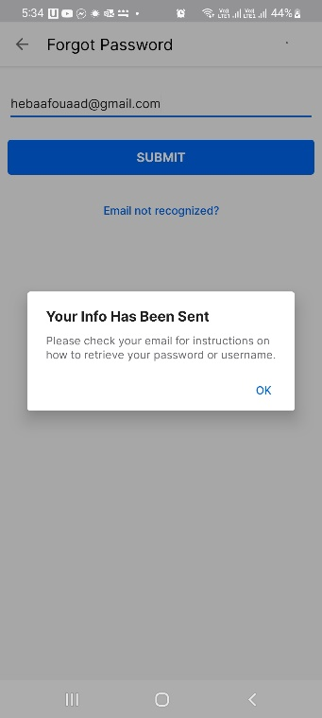Bug1:

Title: When unregistered user try to forget a password, there’s no error message appears

Reproducible Steps:

1. Open app
2. Tab on forget password
3. Write a data for unregistered user
4. Click submit

Attachments:

Affected Devices: Android

Network: WIFI

Severity: low

Priority: medium

Impact: it’s a UX issue because the user will be confused that if he is a registered user or not

1. Bug2:

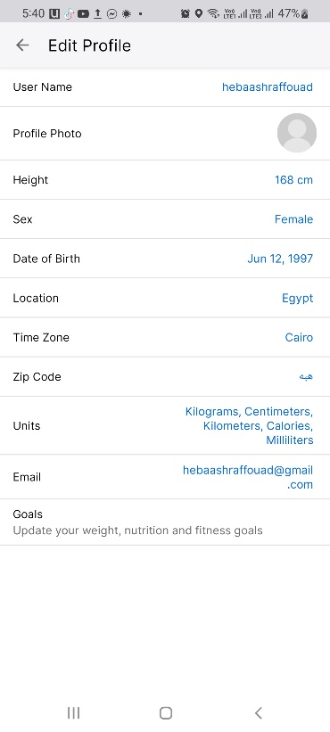Title: When trying to write a wrong data in zip code in edit profile, there’s no error message appears

Reproducible Steps:

1. Open app with logged in user
2. Tab on profile
3. Go to Zip code
4. Write invalid data
5. Click Ok

Attachments:

Affected Devices: Android

Network: WIFI

Severity: High

Priority: medium

Impact: This issue maybe impact in Security of the system

1. Bug3:

Title: Dashboard does not appears in landscape mode

Reproducible Steps:

1. Open app with logged in user
2. Try to landscape the mobile while you’re on the dashboard

Attachments:

Affected Devices: Android

Network: WIFI

Severity: low

Priority: low

Impact: UX issue

1. Bug4:

Title: Not all user’s contacts appears in invitation contact

Reproducible Steps:

1. Open app with logged in user
2. Click on more
3. Click on the account name
4. Click on add friends
5. Click on contacts
6. Check the contacts

Attachments:

Affected Devices: Android

Network: WIFI

Severity: low

Priority: low

Impact: Technical issue

Trello:

1. Bug5:

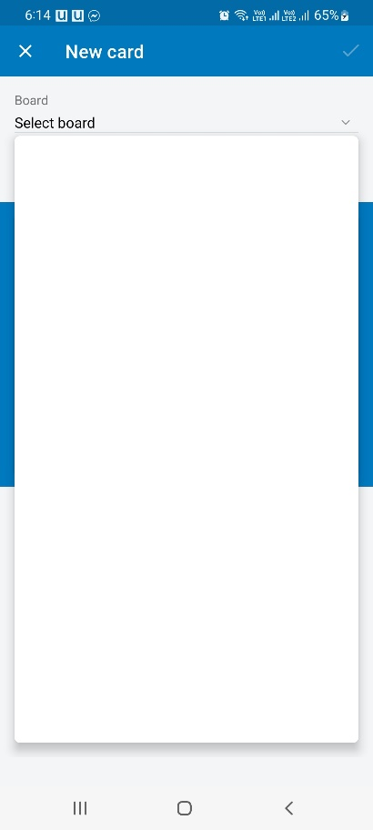Title: When user need to add new card, the select board options does not appears when there’s no boards in the user, there’s no message to describe this

Reproducible Steps:

1. Open app with logged in user
2. Click on Home
3. Click on new card
4. Click on select board

Attachments:

Affected Devices: Android OS 12

Network: WIFI

Severity: low

Priority: low

Impact: UX issue